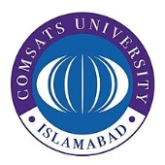**COMSATS University Islamabad,**

**Abbottabad Campus**

**Web Technologies**

(Project)

**Project Title**

**Real Estate property**

***By***

**Ikramullah CIIT/FA21-BCS-237/ATD**

**Mueed Ahmad CIIT/SP21-BCS-059/ATD**

***Submitted to*Bushra Mushtaq**

***Bachelor of Science in Computer Science (2021-2025)***